Pine View Middle School Plan for College & Career Readiness (CCR)
(4 yr. Plan)
(http://pvmscounseling.weebly.com/)

Date: ________ Name: ______________________ Parent Signature:_______________

Occupational Goal: ___________________________________ College/University/Tech School: ___________________

Subject Areas | 9th Grade |  | 10th grade |  | 11th grade |  | 12th grade |  | Total Credit
Language Arts  (4 minimum) | Language Arts 9 | 1 | Language Arts 10 | 1 | Language Arts 11 | 1 | Language Arts | 1
Math (3)  (Secondary Math & higher) | Math | 1 | Math | 1 | Math | 1 | (College Bound) | (1)
Science (3) | Earth Science | 1
Social Studies (3.0) | World Geography | .5 | World Civilization | .5 | US. Studies | 1 | US. Gov./ Citizenship | .5
Healthy Lifestyles (2)  (0.5 Health / 1.5 PE.) | Physical Skills | .5 | Fitness for Life | .5 | Health | .5
Fine Arts (1.5)
CTE (1)
(Career & Technical Ed.)
Business Office (.5) | Business Office | .5
Financial Literacy (.5) |  |  |  |  |  |  | Financial Literacy | .5
Electives (14) |  |  | ACT Aspire Prep Test |  | ACT Test  ***ASVAB
Total Credits 32
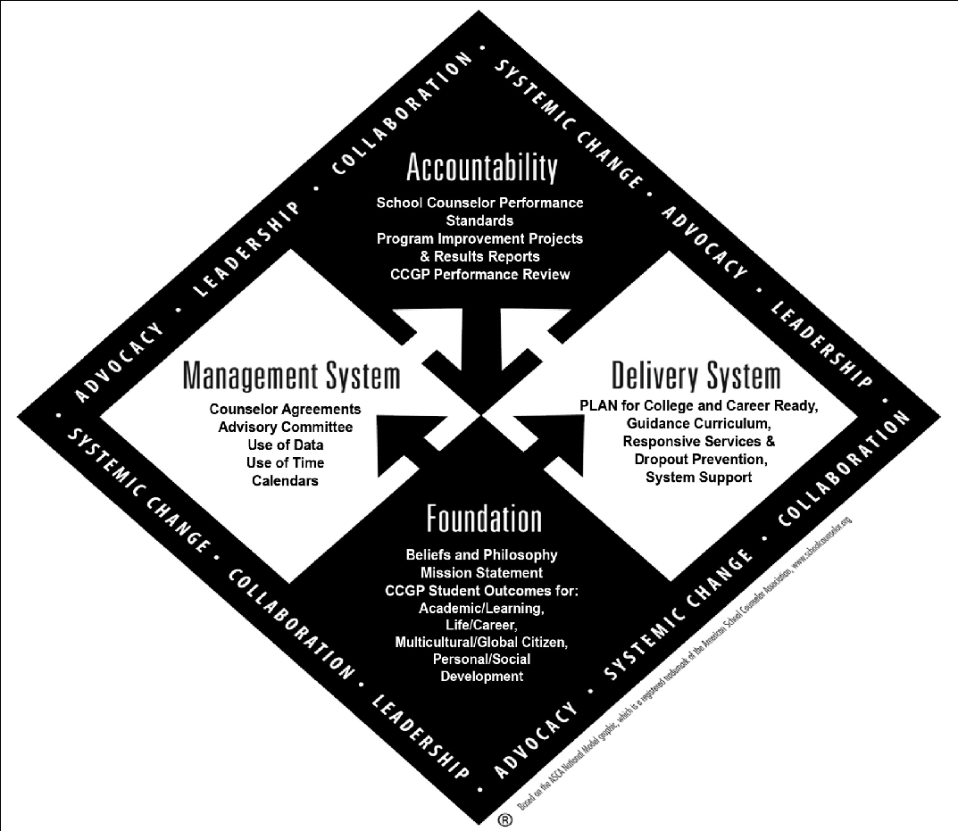
Utah Scholars NCAA Eligibility Requirements CTE / Technical School
http://www.utahscholars.org/ http://web1.ncaa.org/ECWR2/NCAA_EMS/NCAA_EMS.html# Go to - CTE Pathways -
4 Language Arts 4 English (Language Arts) http://schools.utah.gov/cte/pathways.html
4 Math 3 Math (Algebra I or higher) https://utahfutures.org/Portal.aspx
3 Science (Lab-based) 2 Science (one must be a lab science)
3.5 Social Studies 2 Social Studies ACT Website: www.actstudents.org
2 Foreign Language 1 year of additional English, math or science
4 Years of additional core courses *** (Armed Services Voc. Aptitude Battery)
Notes:
____________________________________________________________________________________________________________________
_____________________________________________________________________________

_____________________________________________________________________________

_____________________________________________________________________________________________
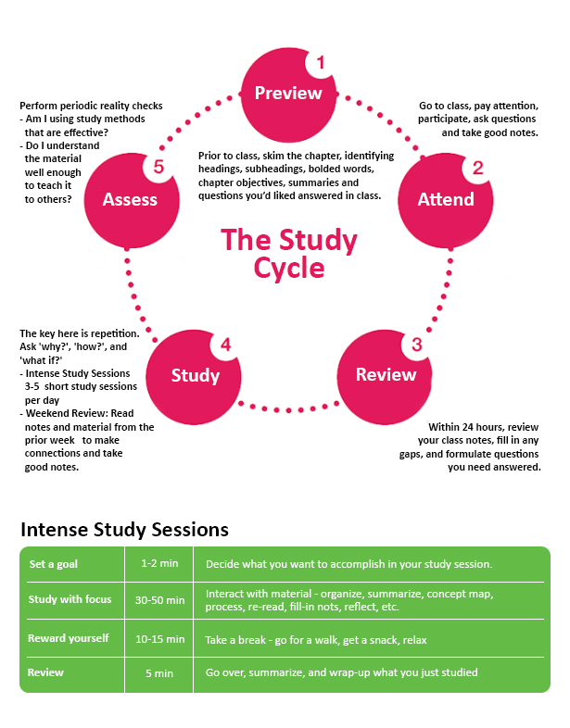 | Next Step Research Tools  College Information/Planning:  - Utah Futures  https://utahfutures.org/choosing/school  - College Board  https://bigfuture.collegeboard.org/?navId=www-cp  - Utah Colleges and Universities  https://www.utah.gov/education/colleges.html  - Step Up Utah  https://stepuputah.com/grade/8th-grade/  Scholarships/Financial Aid:  - Financial Aid, Scholarships, and Students Loans 101  https://lendedu.com/blog/financial-aid-scholarships-student-loans-101-course  - Washington County School District Scholarship Directory  http://secondaryed.temp.washk12.org/academics/scholarships  - College Board Scholarship Search Engine  https://bigfuture.collegeboard.org/scholarship-search#  - FastWeb Scholarship Search Engine  https://www.fastweb.com/  - Step Up Utah  https://stepuputah.com/paying-for-college/  Career Exploration:  - O*Net Interest Profiler  https://www.mynextmove.org/explore/ip  - Utah Futures  https://utahfutures.org/middle-school  Testing Information:  - What is the ACT and why is it important?  https://www.princetonreview.com/college/act-information  - ACT FAQ  http://www.act.org/content/act/en/products-and-services/the-act/help.html  - SAGE Testing General Information  http://sageportal.org/resources/?section=1-general-family

